
USN | 1 | M | S

(Autonomous Institute, Affiliated to VTU)
(Approved by AICTE, New Delhi & Govt. of Karnataka)
Accredited by NBA & NAAC with ‘A+’ Grade

SEMESTER END EXAMINATIONS – MAY 2022
Program | : | B.E. : Common to all Programs | Semester | : | I
Course Name | : | Basics of Civil Engineering and Mechanics | Max. Marks | : | 100
Course Code | : | CV14 | Duration | : | 3 Hrs

Instructions to the Candidates:
- Answer one full question from each unit.
- Draw neat relevant figures wherever necessary.
- Assume missing data suitably.

 |  | UNIT- I
1. | a) | Justify the scope of Civil Engineer as a Structural Engineer, Transportation Engineer and Geotechnical Engineer and their roles in the socio economic development of the nation? | CO1 | (10)
 | b) | Briefly explain the properties of Brick, Reinforced Cement Concrete and Structural steel as materials of construction? | CO1 | (10)
2. | a) | What do you understand by the term Marginal materials? Give examples, Explain any one marginal material and its application in the field of civil Engineering. | CO1 | (10)
 | b) | List out the soft computing tools available in the respective fields of Civil Engineering? Explain the application of AutoCAD software in Civil Engineering. | CO1 | (10)
 |  | UNIT – II
3. | a) | Discuss briefly on the current and futuristic transportation systems. | CO2 | (10)
 | b) | What do you mean by energy efficient built environment? Comment on LEED ratings. | CO2 | (10)
4. | a) | Bring out the influence of civil engineering projects on the socio economic development of the country. | CO2 | (10)
 | b) | Discuss how the civil engineering projects contribute to the growth of GDP of any country. | CO2 | (10)
 |  | UNIT – III
5. | a) | Define a force? Discuss briefly the classification of force systems. | CO3 | (10)
 | b) | The 26 kN force is the resultant of two forces, one of which is shown in Fig. 5(b). Determine the other force, i.e, F.  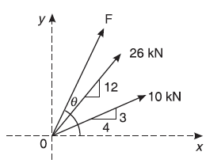  Fig. 5(b) | CO3 | (10)
6. | a) | Find the magnitude, direction and position of the resultant from the point ‘D’ for the system of forces shown in Fig. 6(a).  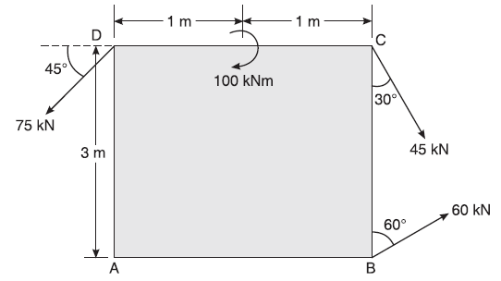  Fig.6(a) | CO3 | (10)
 | b) | State and prove Varignon’s theorem of moments. | CO3 | (06)
 | c) | Explain the principle of transmissibility of force. | CO3 | (04)
 |  | UNIT – IV
7. | a) | With sketch explain different types of supports and mark reaction line. | CO4 | (06)
 | b) | Determine the reactions at the support for the beam shown in Fig. 7(b).  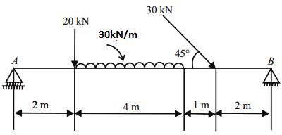  Fig. 7(b). | CO4 | (14)
8. | a) | Briefly explain:  i) Angle of friction ii) Angle of repose and iii) Cone of friction. | CO4 | (06)
 | b) | Find the least value of P required to cause the system of blocks shown in Fig.8(b). to have impending motion to the left. Take µ = 0.2.  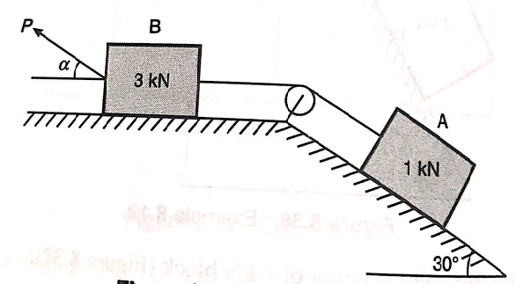  Fig. 8(b). | CO4 | (14)
 |  | UNIT – V
9. | a) | Find C.G. of the shaded area, Fig. 9(a) with respect to given X and Y axes.  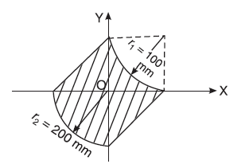  Fig. 9(a) | CO5 | (10)
 | b) | Locate the centroid of quadrant of circular lamina from first principle. | CO5 | (06)
 | c) | Briefly explain: (i) Angle of friction and (ii) Angle of repose. | CO5 | (04)
10. | a) | State and prove perpendicular axis theorem. | CO5 | (05)
 | b) | Determine the moment of inertia of Fig. 10(b) about its centroidal y-axis.  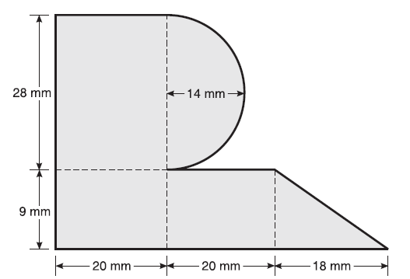  Fig. 10(b) | CO5 | (15)

****************

